P R E S S R E L E A S E

Get together for Robotics:
The beginning of easier, more standardized robot programming

Karlsruhe, Germany – November 21, 2022: Leading robot experts and PLC manufacturers from more than 20 companies met in Nuremberg, Germany on November 16, 2022 to exchange ideas about activities in, and the future of, robot programming. The ‘Get together for Robotics’ was organized by PROFIBUS & PROFINET International (PI) to further advance cross-organization standardization in robot programming together with PLCopen (motion control) and the VDMA/OPC Foundation (VDMA OPC Robotics Initiative). This is based on the Standard Robot Command Interface, or SRCI for short. This is a standardized data interface between the PLC and the robot controllers which was defined and published by a new PI working group last year.

There is great desire for the increased use of robots in industry. The area of application of robot systems is growing, and their complexity is also continuing to increase. Robot experts are hard to come by, though, and the amount of training required is currently substantial. This being the case, the number of robots currently being sold today is far below what’s possible. Thanks to standardization, access to this technology has become much simpler, which also makes it easy for users to utilize various different robot and PLC systems in their own systems without manufacturer-specific knowledge. At the same time, there aren’t any costs for integrating the robot program into the system/machine, as the robots are programmed directly in the system controller and operated using a system control panel.

Regarding the situation, PI Chairman Karsten Schneider said, “The current status is characterized by the fact that many solutions in the field of robotics are only barely economical, or not economical at all, due to a lack of harmonization. New applications have to be ‘redeveloped,’ so to speak, for each system, rather than transferring them from one system to the other. Harmonization and standardization remedy this and will act as enablers for opening up new applications and markets.”

With this event, a PI-initiated joint working group with the named cooperation partners was kicked off with the goal of gaging the potential for harmonization and, building upon this, finding a solution for seamless data transfer between robots, PLCs and other involved devices.

***

Image: ‘Get together for Robotics’ – a PI-organized joint working group intended to further advance cross-organization standardization in robot programming.
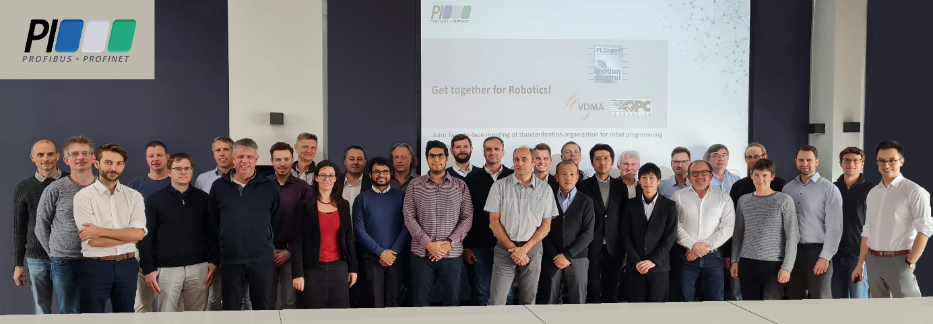
Press contact:
PI (PROFIBUS & PROFINET International)
PROFIBUS Nutzerorganisation e. V.
Barbara Weber

Haid-und-Neu-Str. 7

D-76131 Karlsruhe, Germany
Phone: +49 07 21 986 197-49
Barbara.Weber@profibus.com
http://www.PROFIBUS.com
The text of this press release is available for download at www.profibus.com.

